MATH2059 Numerical Methods

Homework 1 Report

Ahmet Abdullah Gültekin

150121025

Source: Help Matlab

This report includes solution of four matlab problems which is given as homework.Methods, figures and solutions are as follows:

1. Butterfly Curve

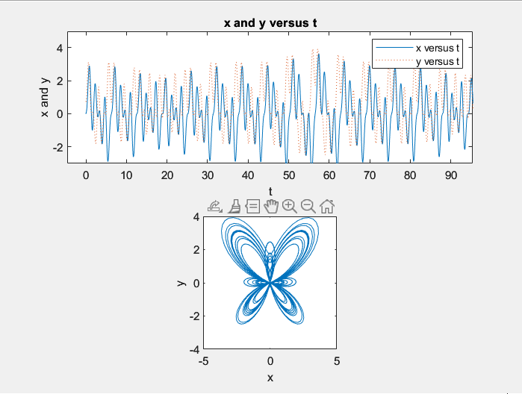

Figure 1.1

As we see in the figure 1.1, formula and the typed codes gives us a butterfly curve.

Used functions are as follows:

subplot, plot, legend, title, xlabel, ylabel, axis square

1. Butterfly Curve in Polar Coordinate

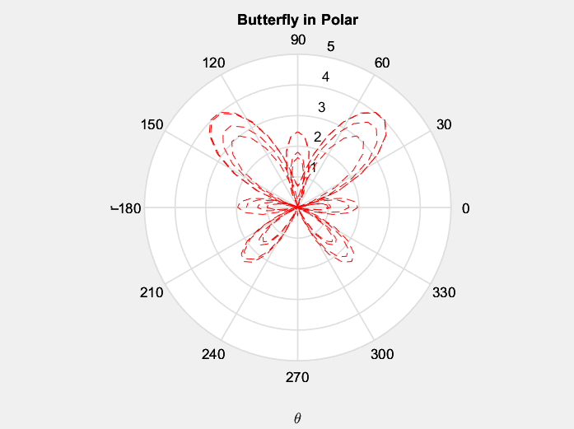

Figure 2.1

As we see in the figure 2.1, formula and the typed codes gives us a butterfly curve in polar coordinate system.

Used functions are as follows:

polar, title, xlabel, ylabel

1. Sin(x) function

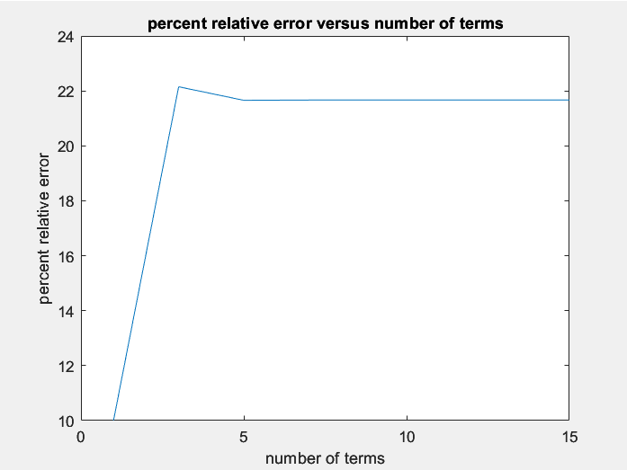

Figure 3.1

As we see in the figure 3.1, formula and the typed codes shows us a error percentage.

We calculated the error percentage of sin(x) with specified values.

Used functions are as follows:

plot, cumsum, title, xlabel, ylabel, factorial

1. Find Difference of Function’s min-max Values

Figures with their formulas:

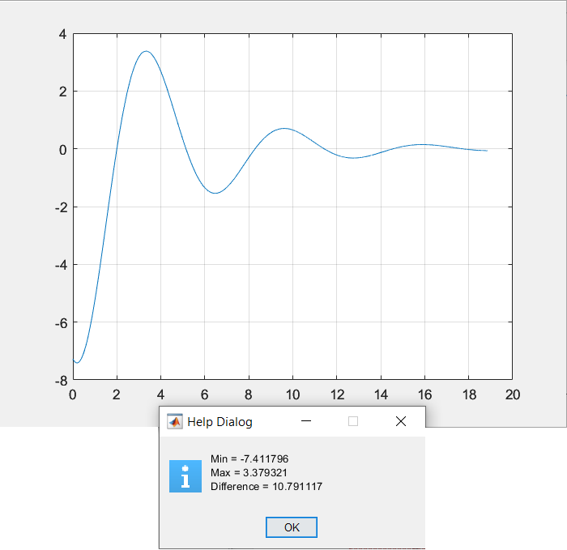

Figure 3.1

8 \* exp(-0.25 \* t) \* sin(t - 2)

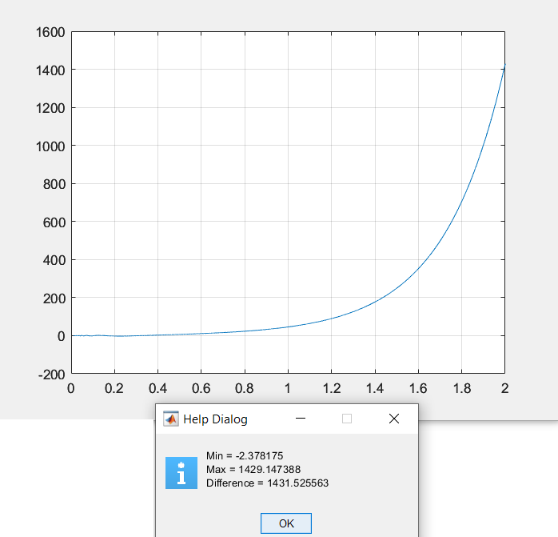

Figure 3.2

exp(4 \* x) \* sin(1 / x)

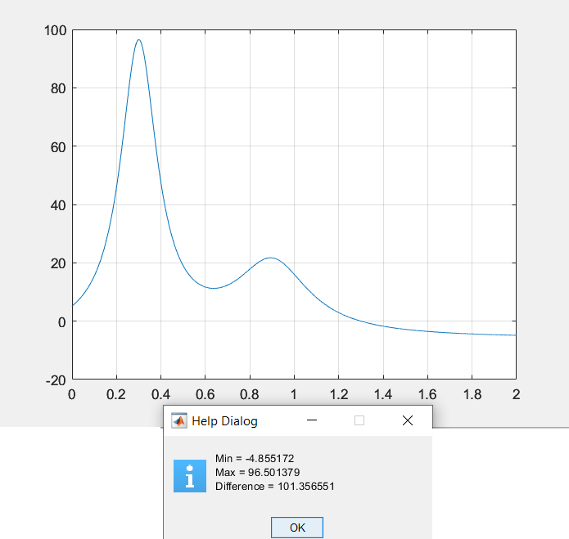

Figure 3.3

Special function of Matlab “Humps”

As we see in the figures, formula and the typed codes shows us differences.

We calculated the differences of functions max-min in certain range.

Used functions are as follows:

function, linspace, title, xlabel, ylabel, grid, uiwait, helpdlg